

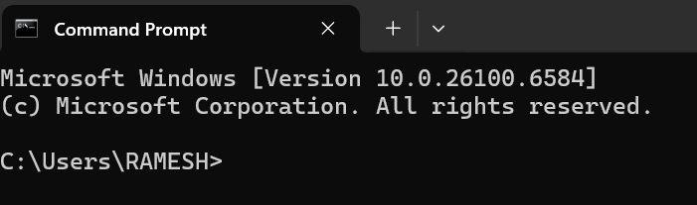

Disclaimer: The content is curated from online/offline resources and used for educational purpose only
Code Repository
LAB MANUAL
Initializing a Git Repository – Create a New Local Repository and Check Repository Status
Objective:
- To create a new local Git repository using the git init command
- To understand the structure of a Git-enabled folder
- To use git status to view changes and track file states in the repository
Equipment Required:
- A computer with Git installed
- Git Bash (Windows) / Terminal (Linux or macOS)
- Basic text editor (Notepad, VS Code, etc.)
Prerequisites:
- Basic knowledge of command line operations
- Git must be installed and configured (user.name and user.email)
- Familiarity with file systems and directories
Problem Statement:
As a developer starting a new project, you want to use Git to track changes in your files. Your task is to initialize a new Git repository in a local folder and check its status to ensure Git is ready to track file changes.
Procedure:
Step 1: Open Terminal or Git Bash
- Launch Git Bash (Windows) or Terminal (macOS/Linux)

Step 2: Create a New Project Folder
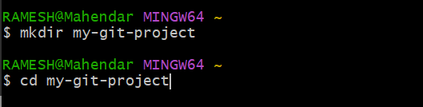

Step 3: Initialize a Git Repository
You should see:Initialized empty Git repository in <your_path>/.git/
Step 4: Create a New File
Step 5: Check Repository Status
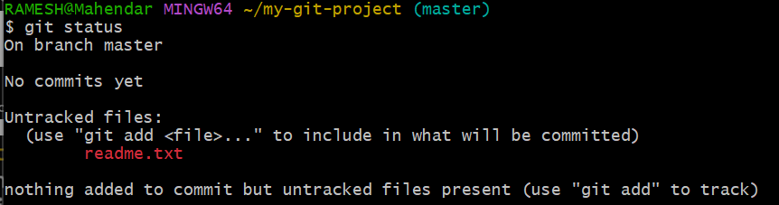
Step 6: Stage and Commit the File
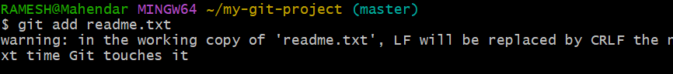
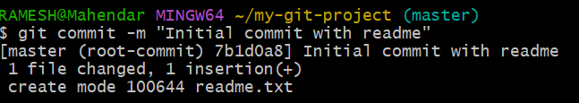
Step 7: Verify Final Status

It should now show: nothing to commit, working tree clean

